**DAILY ONLINE ACTIVITIES SUMMARY**

|  |  |  |  |  |  |  |  |  |
| --- | --- | --- | --- | --- | --- | --- | --- | --- |
| **Date:** | **02/06/2020** | | | | | **Name:** | **RITIKA KULKARNI** | |
| **Sem& Sec** | **4thSEM. & ‘B’ SEC.** | | | | | **USN:** | **4AL19CS403** | |
| **Online Test Summary** | | | | | | | | |
| **Subject** | | **---** | | | | | | |
| **Max. Marks** | | **---** | | **Score** | | | **---** | |
| **Certification Course Summary** | | | | | | | | |
| **Course** | **Python for Machine Learning** | | | | | | | |
| **Certificate Provider** | | | **Greatlearning**  **Academy** | | **Duration** | | | **5 Hrs.** |
| **Coding Challenges** | | | | | | | | |
| **Problem Statement:**  **Inversion Count: For an array, inversion count indicates how far (or close) the array is from being sorted. If array is already sorted then inversion count is 0. If array is sorted in reverse order that inversion count is the maximum.**  **Formally, two elements a[i] and a[j] form an inversion if a[i] > a[j] and i < j.**  **Input:**  **The first line of input contains an integer T denoting the number of test cases. The first line of each test case is N, the size of array. The second line of each test case contains N elements.**  **Output:**  **Print the inversion count of array.** | | | | | | | | |
| **Status:** | | | | | | | | |
| **Uploaded the report in Github** | | | | | **Yes** | | | |
| **If yes Repository name** | | | | | <https://github.com/ritikakulkarni/QuarantineCoding-JavaCoding> | | | |
| **Uploaded the report in slack** | | | | | **Yes** | | | |

**Certification Course Summary: Today I have learnt about the jupyter notebooks ,how to create a new note book and how to execute the code in the cell provided in the notebook and about some of the keyboard shortcuts which helps to execute the code and to achieve the output and some of the basic data structure hands-on.**

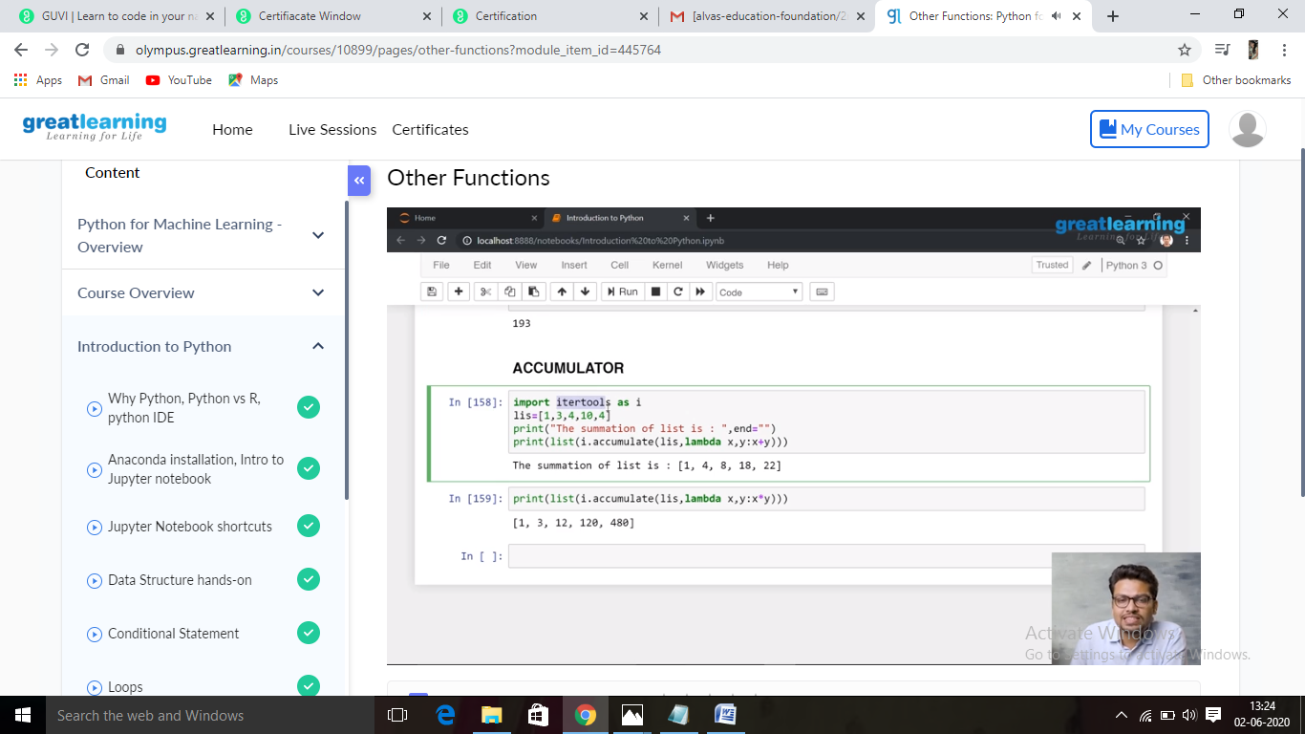

**Online Coding Summary:Online Coding Summary​: Online coding Summary: Today I received one program from Prof.Venkatesh CSE Dept. The program is mentioned above(pg.01). to my GitHub repository and I’ve shared the snapshot below.**

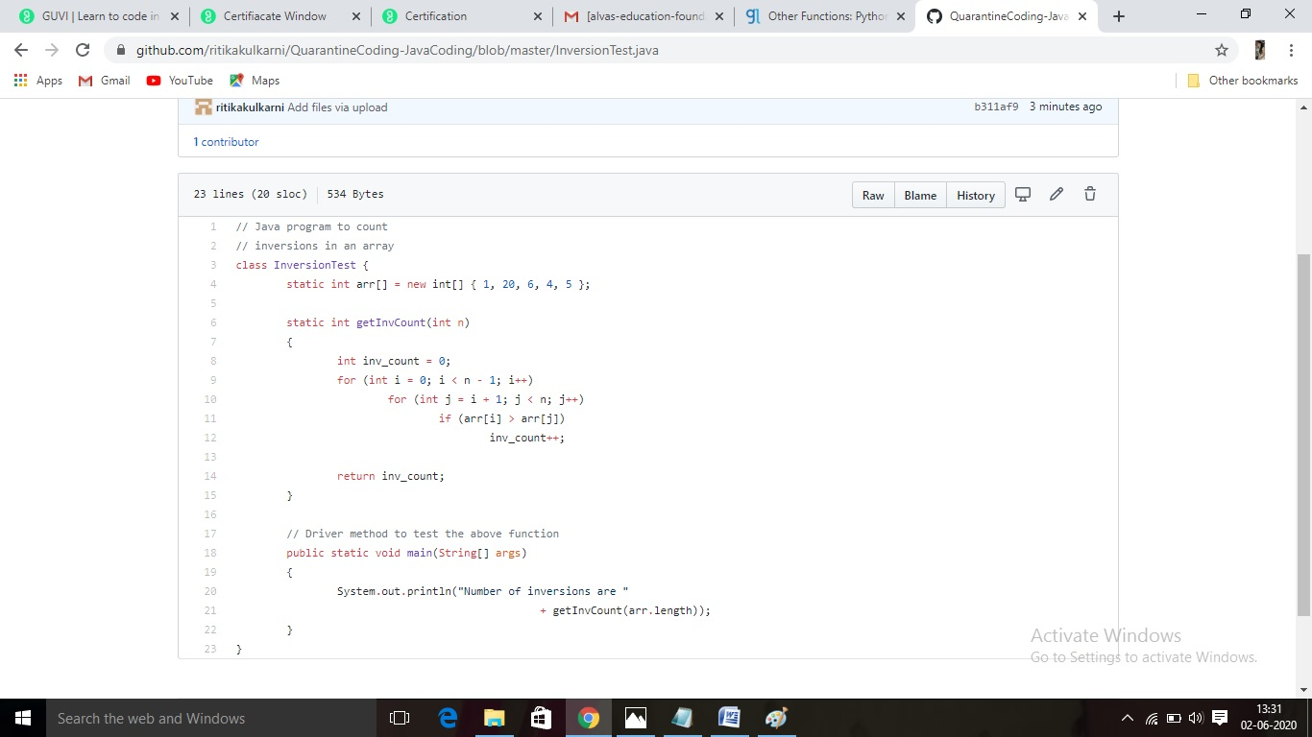

**Thank you.**